Question 1 (2 pts each * 5 = 10 pts)
True/False. Fill the table with T/F answers.
# | Questions | True/False
1 | A data flow diagram (DFD) does not show the external entities that provide data to the system or receive output from the system. | False
2 | The personal interview usually is the least expensive fact-finding technique. | False
3 | Later in the systems design phase, you build a logical model that describes how a system will be constructed. | True
4 | ​System documentation always is up-to-date. | True
5 | Data stores are shown in a context diagram because data stores are external to the system. | False

Question 2 (2 pts each * 5 = 10 pts)
Multiple choice questions. Fill the table with correct letter answers.
# | Questions | Answer:
1 | ​A __b___ consists of horizontal bars, connected with arrows that indicate task dependencies.  a) Gantt chart  b) PERT/CPM chart  c) WBS  d) critical path chart
2 | A _D___ is a central storehouse of information about a system's data.​  a) data stored  b) data repository  c) data cube  d) database
3 | During the __ C ___ of the systems development life cycle (SDLC), the IT staff maintains, enhances, and protects the system.​  a) system implementation phase  b) system analysis phase  c) system support and security phase  d) system design phase
4 | In an interview, ___A__ are questions that ask a person to evaluate something by providing limited answers to specific responses or on a numeric scale.  a) open-ended questions  b) fact-finding questions  c) range-of-response questions  d) numerical questions
5 | Knowledge management systems use a large database called a(n) __A___ that allows users to find information by entering keywords or questions in normal English phrases.​  a) knowledge base  b) inference base  c) knowledge database management system  d) if-else rules database

Question 3 (2 pts each * 5 = 10 pts)
Matching question. Fill the table with correct letter from matchings.
# | Questions | Answer:
1 | This provides various graphical tools, such as use case diagrams and activity diagrams. | C
2 | These methods develop a system incrementally, by building a series of prototypes and constantly adjusting them to user requirements. | D
3 | Systems analysts use this kind of question when they want information that is more specific, or when facts must be verified. | B
4 | These are the kinds of questions that are useful when a systems analyst wants to understand a larger process or draw out the interviewee's opinions, attitudes, or suggestions. | E
5 | One of its risks is that a system might work well in the short term, but the corporate and long-term objectives for the system might not be met. | A

# | Matchings
A | Rapid-Application Development
B | Closed-ended
C | Unified Modelling Language (UML)
D | Agile method
E | Open-ended

Question 4 (Short answer questions 5pts * 4 = 20 pts)
Fill the table by answering questions. Make sure, you have answered each sub-question.
Questions: | Answers:
What five questions typically are used in fact-finding? What other question does the Zachman Framework include? Is the additional question important? | Who? Will be working with the system  When? When the problem will be resolved  How? How the problem impacts system  What? What is the problem  Where? where the problem occurs  The additional question is always “why” .it is important for it help in understanding the reason for doing the project.
What are the three main task patterns? Provide an example of each. | Dependent tasks –this are tasks that depend fully on each other  Multiple successor tasks .This are tasks which depend on other tasks and cannot start without the end of the previous tasks. Example system maintenance happens when system have been implemented  Multiple predecessors .Tasks can never start until multiple tasks are completed before the task start .example system integration ,other system components have to be completed
What are the four organizational levels common to many businesses? Which level typically requires data that supports long-term strategic planning and the overall business enterprise? What level of worker might rely heavily on transaction processing systems? | Most business have four common organizational levels which are supervisors and team leaders, operational employees. Managers and knowledge workers and finally the top managers.  Data supporting long-term strategic planning is needed by top managers  Transactions processing systems are heavily relied by supervisors and team leaders who have to ensure that the system the company’s operations are achieving goals and company objectives
Define polymorphism, and provide three examples. | Polymorphism basically means having many forms ,while in programming it is an interface which can be implemented in different ways, Example GOOD MORNING message might mean for parents to head out for work while it can me time to wake up and take breakfast and go to school for a child

Question 5 (Essay question 10 pts)
Write half-page to one page summary about your findings on a topic: Object-oriented analysis, and its advantages. Define key Object-oriented analysis terms. You must reference minimum 3 articles/videos.

Summary (Do not copy-paste, use paraphrasing):

Without a good way to define object oriented analysis is an a tool of analysis which is interactive that is applied during when developing systems .The aim of the method is to implement the functional requirements of the system when trying to be independent from implementation factors .when developing a system using OOAD practices object oriented Analysis will be used to analyze and make sure that every system details is analyzed to the system requirements. This type of analysis have few problems ;The method is not favorable for any procedural programming ,problems and systems which are not developed in accordance with objects oriented programming can never experience the power of OOAD analysis .OOA is not suitable for small and suitable applications .
Objected analysis and design is a software development technical approach which mains purpose is analyzing the designs of the system by applying objected oriented programming methods .The model applies visuals and object that guide the system developers and relevant stakeholders and project leaders during the system application stages. Advantages of using the system include, It focuses on the system objects unlike the structured analysis, and The encapsulation principles when deployed in the system ensure the system developed have secured data. The object oriented analysis assures virtual modularity.

References (URL links):
1. https://airbrake.io/blog/design-patterns/object-oriented-analysis-and-design
2. https://www.umsl.edu/~sauterv/analysis/488_f01_papers/wang.htm
3. https://www.tutorialspoint.com/object_oriented_analysis_design/index.htm

Question 6. Problem solving (20 pts)
You are given below UML Class diagram. Create object diagram for the following scenario:
Guest name – Alaa (address: Salmiya, country: Kuwait) – made 2 Bookings. First booking on 2 Dec 2020 for 3 days. Second booking on 15 Dec 2020 for the duration of 5 days.
First booking reserved one room (room number 15, price 40 KD with 45sq.m. area)
Second booking reserved two rooms (room number 24, price 70KD with 50sq.m, and another room number 21, price 60KD with also 50sq.m)
P.S.: Draw diagram on a piece of paper, and write your name on it. Take photo of your diagram, and place it below.
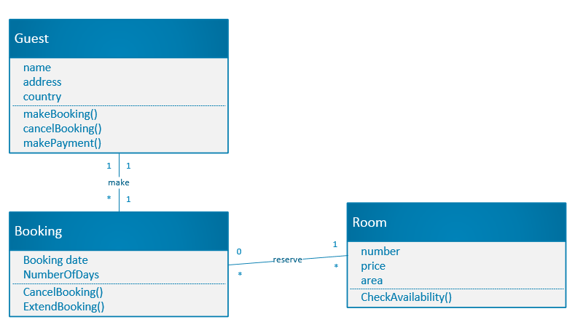
Your diagram (14 pts):

Diagram analysis. Answer below questions:
Questions: | Answers:
How many objects in your diagram? (2pts) | three
How many attributes in the Assessment class? (2pts) | Two
How many methods Student class have? (2pts) | three

Question 7. Problem solving (20 pts)
Avenues Mall have opened new Concert Hall. They asked you as an expert IT analyst to make structural analysis for their new system.
Below is the system description:
Concert Hall are booked for different events. When agencies submit requests with particular date to make bookings, the system checks the availability on the given date. System will send a availability status message to the agency. When the booking is made, the agency is billed (system generates an invoice), the system will generate a cleaning request to the cleaning stuff, so that they will prepare concert hall for that date. The system also produces various reports for the Accounting department.
Create Context diagram for above scenario. Draw a diagram on a piece of paper, write your name on it, and place your diagram below.
Your context diagram (14 pts):

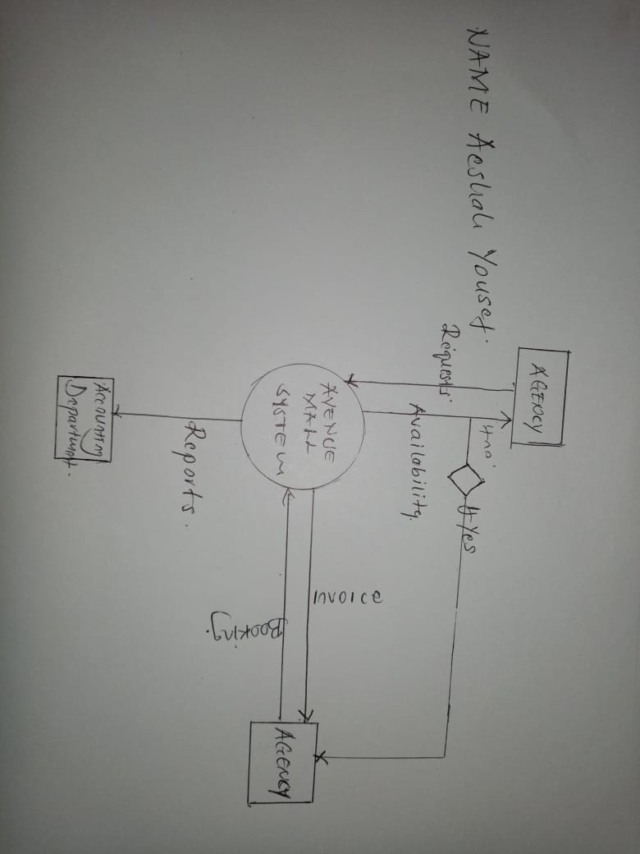

Diagram analysis. Answer below questions:
Questions: | Answers:
How many external entities in your diagram? (2pts) | Three
How many Data flow IN to the system? (2pts) | Three
How many Data flow OUT from the system? (2pts) | Four

